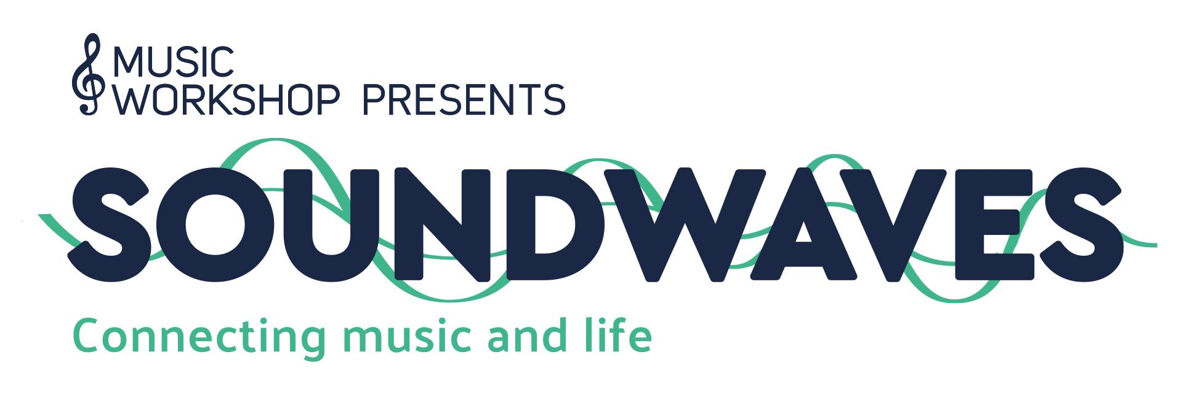

CONTACT INFORMATION:
Deb Postlewait, Project Manager
503.213.3055
deb@vividtech.net
RELEASE DATE:
Thursday, July 21, 2022

MUSIC WORKSHOP PRESENTS SOUNDWAVES
AT THE RESER
Connecting music and life

BEAVERTON, OR, July 2022 — Music Workshop’s Soundwaves program will bring youth ages 8 and up and their families to The Patricia Reser Center for the Arts for eight interactive performances with professional musicians. Concerts will be held Aug. 16, 18, 23 and 24 and will include performances by Thomas Lauderdale and China Forbes of Pink Martini, DJ Prashant, Thunderstorm Artis, and The Portland Cello Project.

The musicians represent a variety of genres and cultures, and will tell their stories, and share their music. Audience members will support the production itself, having the opportunity to engage with the musicians.

The concerts are free and open to the public, but reservations are REQUIRED. Youth under the age of 18 must be accompanied by an adult. Tickets will be available starting Friday, July 22, 2022.
For tickets and more information, go to TheReser.org.
Funding for this project comes from the Oregon Legislature supported by Oregon Department of Education and overseen by Oregon Association of Education Service Districts.

Portland based Music Workshop is a 501(c)3 non-profit that creates and provides K-8 teachers with free access to high-quality, culturally responsive music education to more than 3.5 million students worldwide. Learn more at www.MusicWorkshopedu.org.

###

